Student's name: _________________________________________
Pizza toppings
Ben is having a birthday party. He wants to serve home-made pizzas at his party. His mum asked him to ﬁnd out what pizza toppings his friends like. Ben decided that he would survey his friends to ﬁnd their favourite toppings and display the data in a picture graph.

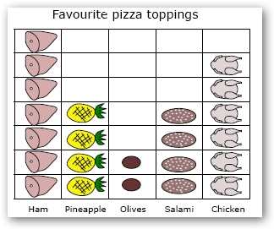
Answer the following questions:

Why did Ben and his mum want to collect the data?

How many toppings could the guests choose from?

How could Ben have recorded the data?

How many people were asked altogether?

Complete the table on the next page.

Fill in the table using the information displayed in the picture graph.
 | Favourite pizza toppings
Ham | Pineapple | Olives | Salami | Chicken

