Activity 4: Collaborative task using Google Drive
Instructions for:
- Presenter - sharing with participants (before session)
- Participants - opening and editing (during session)

Presenter – Before session
- Save Activity 4: Linking Quality Teaching model with differentiation elements to your computer.
- Using Google Chrome as your browser, access Google Apps through the DEC staff portal page. If not already installed, go to ‘My learning tools’ and select Google Apps>Add to My Essentials. The icon is now displayed in your Essentials area. Choose it to open.
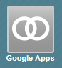
- Select ‘Drive’ under Collaborate & Present.
- Select the Upload arrow and choose ‘Files…’
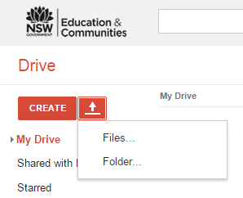
- Find the document on your computer and open it. The document is now listed under ‘My Drive’. Open it from the list.
- To share the document, either select the Share button (top right) or select Share in the ‘Upload complete’ mini-screen.
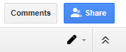
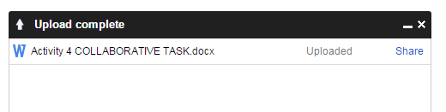
- Enter the names or email addresses of participants. Add a note if you wish. Ensure ‘Can edit’ is selected from the drop-down menu. Select ‘Send’. Participants will receive an email with the document name hyperlinked.
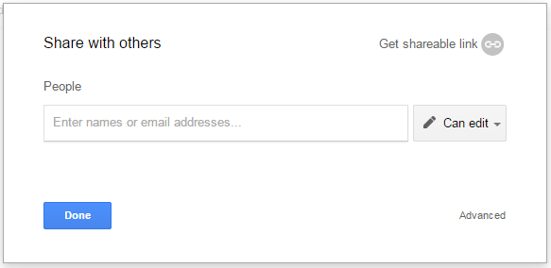
- To enable editing, participants must access the ‘Open’ menu and ‘Open with Google Docs’. For existing Google Apps users, the document will automatically open for editing in their Drive.
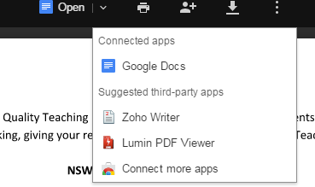

Participants – During session
- Open the email containing the document and either select the hyperlinked document name to open it or select Open in Docs.
- Existing Google Apps users: the document will automatically open for editing in your Drive.
New Google Apps users: to enable editing, access the ‘Open’ menu and ‘Open with Google Docs’.
- Edit the document in your group. Changes are automatically saved in Drive.
- Select ‘Share’ button to send your edited version to others. Enter names in the ‘Share with others’ field and select Send. Recipients will receive an email containing a link to the document.
- See the File drop-down menu for other options.

