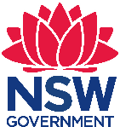 Early Stage1 Geography, English, Science and Technology – Do we need a train at Chullora?
Chullora Public School has approximately 300 students and caters to the needs of a low socioeconomic status and high non-English speaking background community. The school is organised into stage-based learning teams led by a dedicated and skilled executive team. Our students have diverse learning needs. As well as providing enrichment activities, the school has a comprehensive learning support program for students in need of additional assistance.

Do we need a train at Chullora?
Early Stage 1 – duration 8-10 weeks

Unit context
This unit was written by Leyla Derbas (Assistant Principal ES1) of Chullora Public School.
It was created, trialled and peer reviewed as part of a professional development program in inquiry-based learning for primary and secondary school teachers. The professional development courses were part of a pilot partnership between the NSW Government’s Sydney Metro transport agency and Western Sydney University. Facilitated by Western Sydney University’s Education Knowledge Network, the professional development program aimed to develop teacher expertise in inquiry-based learning using a real-life example of a major infrastructure project in delivery stage.
The unit is aligned to © NSW Education Standards Authority (NESA) syllabuses, specifically the Science and Technology K-6 Syllabus (2017), Geography K-10 Syllabus (2015) and the English K-10 (2012) Syllabus. The unit was implemented as an open inquiry and evolved to become a combination of structured, guided and open inquiry. The unit evolved as it was implemented. After each learning experience, the next learning experience would be planned, based on student interests.
A complementary unit ‘How are you feeling?’ was taught alongside this unit for students in the class with autism spectrum disorder and/or moderate intellectual disability.
Sydney Metro is Australia’s biggest public transport project.

Syllabus links
General capabilities and cross-curriculum priorities | Outcomes | Skills | Concept
- Critical and creative thinking  - Ethical understanding  - Personal and social capability  - Literacy  - Work and enterprise | By end of the unit, student/s will:  Geography  - GEe-1 identifies places and develops an understanding of the importance of places to people.  - GEe-2 communicates geographical information and uses geographical tools  Science and Technology  - Ste-4MW-ST identifies that objects are made of materials that have observable properties.  English  - ENe-1A communicates with peers and known adults in informal and guided activities demonstrating emerging skills of group interaction.  - ENe-7B recognises some different purposes for writing and that own texts differ in various ways | Student learn to:  Geography  Acquiring geographical information  - pose questions and make observations (ACHGS001)  Locating places  - investigate how the location of places can be represented, for example: (ACHGK001)  - location of familiar and local places on maps  - description of the location of places  Communicating geographical information  - present information (ACHGS005)  - reflect on their learning (ACHGS006)  Science and technology  - share observations and ideas based on guided investigations (ACSIS012)  - pose questions about familiar objects and events.  - identify the technologies needed to achieve designed solutions (ACTDEP005)  - plan, design and evaluate a product considering an identified need or opportunity (ACTDEK001) DesT  - identify and describe how the properties of different materials suit their design purpose (ACTDEK004) DesT  English  - listen to and respond orally to texts and to the communication of others in informal and structured classroom situations (ACELY1646) | Student learn about:  Geography  Place: the significance of places and what they are like, for example, the places students live in and belong to, and why they are important.  Space: the significance of location and spatial distribution, and ways people organise and manage the spaces that we live in, for example, the location of a place in relation to other familiar places.  Environment: the significance of the environment in human life, and the important interrelationships between humans and the environment, for example, how and why places should be looked after.  Science and Technology  The material world: the characteristics and observable properties of substances and materials.  Students generate and develop design ideas and solutions that they communicate with labelled drawings and models and through the use of digital technologies where appropriate.
Geographical tools integrated into this unit: Maps (M) − pictorial maps; Fieldwork (F) − observing and recording data; Spatial technologies (ST) − virtual maps; Visual representations (VR) − photographs, illustrations, story books, multimedia.

Broad focus
How does our community meet the needs of people?

Generative question/s
- What are trains?
- What is inside the train?
- What are trains made of?
- Why is the train underground?
- Why do we need trains at Chullora?
- Where would we put a train station at Chullora?
- Does Chullora have a train station?
- Why is the train on the track
Syllabus main focus (outcome, skill or concept) | Teaching, learning and assessment | Resources and technology
Geography  GEe-1 poses questions and makes observation (ACHGS001)  Science and Technology  STe-4WS explores their immediate surroundings and ask questions about their observations and experience.  English  ENe-1A listen to and respond orally to texts and to the communication of others in informal and structured. Classroom situations  Critical and creative thinking  - Using information and ideas and arguments to respond to and compose texts.  - Learning to think broadly and deeply students use reason and imagination to direct their thinking for different purposes. | Learning experience 1  - Display an aerial view of Chullora and ask students to identify significant areas/places.  - Discuss the symbols that are found on maps and what they mean.  - Ask students to describe how they travel to school each day.  - After the discussion tell students they are about to go on a 'wondering' adventure where they will be looking at special things. They will need to start wondering about what they see and what they might like to know more about.  - As students attend the 'I wonder' adventure (a room of objects to prompt interest in Sydney Metro), note down student discussions, observations and wonderings. Student curiosity and thoughts should inform the next teaching experience. | - Interactive white board  - Map of Chullora and map of Bankstown showing the railway lines  - Artefacts of Sydney Metro, such as train sets, replica trains, pictures, maps of the area  - A3 photocopy of Chullora and Bankstown maps
Geography  Locating places  - Investigate how the location of places can be represented, for example (ACHGS001)  - Location of familiar and local places on maps  - Description of the location of places  Critical and creative thinking  - Investigate geographical information, concepts and ideas through inquiry-based learning.  - Think logically when evaluating and using evidence  - Encouraged to be curious and imaginative in investigations and fieldwork  Science and Technology  Materials are selected to suit specific purposes  - Identify and describe how the properties of different materials suit their design purpose (ACTDEK004) DesT  - Plan, design and evaluate a product considering an identified need or opportunity (ACTDEK001) DesT | Learning experience 2  - Display pictures of familiar places such as Chullora Marketplace, Roberts Park, Luna Park, Sydney Aquarium, Sydney Harbour Bridge, Sydney Opera House and/or Bankstown Shopping Centre. Mark their location on a map.  - Turn and tell – What are the different ways that we travel to these places?  - Students build methods of transport using different concrete materials.  - Circle time – Students present their model and reflect on:  - The type of transport they built  - Where it could take them  - Ask students 'What would be the quickest way to get to Luna Park?'  L3 integration  - Students write about how they get to familiar places during literacy centres  Assessment 1  - Students identify and make different modes of transport. Through discussion they identify the fastest mode to travel in the suburbs | - Concrete materials such as Lego, Mobilo, paper, cardboard, straw, pipe cleaners, playdough, tissue boxes, egg cartons, buttons, water bottles, lids, cupcake tins.  - Interactive white board.  - Transport pictures with labels and familiar places with labels.
Geography  Visual representations - photographs, illustrations, story books, multimedia.  Critical and creative thinking  - Think logically when evaluating and using evidence  Science and Technology  - Students generate and develop design ideas and solutions that they communicate with labelled drawings and models and through the use of digital technologies where appropriate. | Learning experience 3  - What are trains? What is inside the train?  - Recap previous lesson.  - Using a Know, Want to know, Learnt (KWL)chart ask students the following questions:  - What do you know about trains?  - At the end of the lesson, ask the students:  - What else do you want to learn about trains?  - What have you learnt today?  - Show students a 360 camera walk though of the Sydney Metro train and discuss its features.  - Use the ‘My train’ template and ask students to sketch a model of the inside of a train.  - Students share their sketches and discuss the purpose of their designs. | ‘Sydney Metro: 360 camera walk through new metro train’ (Transport for NSW, 2018) (2 minutes 19 seconds): This is best viewed in Google Chrome.  My Train template on page 12 of this document.  Metro stickers of people  Coloured pencils.
Geography  Critical and creative thinking  Think logically when evaluating and using evidence, testing explanations.  Science and Technology  Explore their immediate surroundings and ask questions, about their observations and experiences.  - Ste-4MW-ST identifies that objects are made of materials that have observable properties.  - Explore the characteristics and properties of materials and components that are used to produce designed solutions (ACTDEK004) DesT | Learning experience 4  - We are learning to identify what materials can be found in a train.  - KWL chart recap on what students learnt about trains from the previous lesson.  - Show students the video of Melbourne’s Metro train interior and ask students to identify the materials that are found in a train.  - Ask students, why were those materials used?  - How about the outside of the train? What is it made of?  - In pairs, students use different materials to create a model of a train. They need to think critically and justify why they have used those materials.  - Students share their model. The teacher asks:  - Why have you used — for —?  - What would change? | Aluminium foil, cotton balls, cellophane, glad wrap, fabric, cardboard boxes, glue, sticky tape.  ‘A tour of Melbourne’s new high capacity Metro train (mockup)’ (ThebusofdoomFSX, 2018) (10 minute 12 seconds):  Interactive white board.  PowerPoint presentation featuring pictures from the ‘I wonder’ day’ held in learning experience 1
Geography  Locating places  - Investigate how the location of places can be represented, for example: (ACHGK001)  - location of familiar and local places on maps  - description of the location of places  Critical and creative thinking  Students are encouraged to be curious and imaginative in investigations and fieldwork  Science and Technology  Explore their immediate surroundings and ask questions, about their observations and experiences | Learning experience 5  - WALT (We Are Learning To) catch a train and know how take care of it.  - Display a map of a train route (namely Bankstown Line). Discuss with children where the train stops.  - Show short videos of trains and train stations such as the ‘London Underground Train’ YouTube video and the train announcement video.  Structure questions to provoke student to think about a train station built in Chullora. | Video: ‘London Underground Train* | Trains for Kids’ (Things That Go TV!, 2013) (31 seconds):  Video: Train announcement ‘DVA #40: Campbelltown – City Circle via Bankstown (Limited Stops)’ (TSE SecretAni, 2017) (30 seconds)  Interactive white board.  Map: Sydney train line.  Map: Satellite image of Chullora map.  Photocopy of Opal cards.
Geography  GEe-2 communicates geographical information and uses geographical tools.  Locating places  - Investigate how the location of places can be represented, for example: (ACHGK001)  - location of familiar and local places on maps  - description of the location of places  Important places  - Investigate the importance of places they live in and belong to, for example: (ACHGK002, ACHGK004)  Students reflect on their learning from the findings of their inquiry.  Critical and creative thinking  Develop and practise critical and creative thinking by using strategies that help them think logically when evaluating and using evidence, testing explanations, analysing arguments and making decisions | Learning experience 6  - Recap last week's lesson on taking the train to Bankstown and show the students another video on Sydney Metro.  - Show students a map of the train line and discuss where the train stops.  - Ask: I wonder why we can’t find Chullora on the train line?  - Students investigate possible reasons.  - Show a Chullora map. Guide student inquiry with questions:  - Does Chullora have a train station?  - Why do we need trains at Chullora?  - Where would we put a train station in Chullora?  - Revisit the map of Chullora and talk about how there is no train station in Chullora/Greenacre. Discuss how we would need to travel to another train station to get to the places we discussed.  - Turn and tell – Do we need a train station in Chullora?  - Give students an aerial satellite map of Chullora and get them to highlight where they would put them map.  - Provide students with a Chullora map and dot stickers. In pairs students decide critically where they would put a train station at Chullora.  - Students share their reasoning and then have another opportunity to decide on another area to place their train station using a different coloured dot.  Assessment 2  - What did you put the train there?  - What would happen if you put it there?  Video students explaining their critical thinking and why they chose that particular place to build a train station. | Dot stickers  A video that provides an introduction to Sydney Metro such as ‘Sydney Metro: Fast Tracking the Future education program an introduction for primary school students’ (Transport for NSW, 2019) (4 minutes 1 second):  Map:Link to Sydney trains network map: transportnsw.info/sydney-trains-network-map  Map: Satellite image of Chullora.
Geography  Important places  - Investigate the importance of places they live in and belong to, for example: (ACHGK002, ACHGK004)  - discussion of why places are special and how people care for them  - explanation of why people need to take care of places  Locating places  - Investigate how the location of places can be represented (ACHGK001)  Critical and creative thinking  Make decisions, thinking deeply about questions. Students are encouraged to be curious and imaginative in investigations and fieldwork and to think creatively about the ways that the places and spaces they use might be better designed, and about possible, probable and preferable futures | Learning experience 7  - Revisit the Chullora map and identify key places.  - Tell students that they are engineers and the government needs their help to rebuild Chullora to include a train station in the suburb.  - On a large piece of butcher’s paper, students will redesign the map of Chullora and think about where they will they put the train.  - Reflection: Now that we have redesigned Chullora to include a train station, how will it benefit the community?  - Questions to prompt thinking:  - What have you changed about Chullora?  - What will the people of Chullora think about it?  - How will they feel?  - How will the train help the people that live in Chullora?  Take pictures of student samples. | Large butcher’s paper, pictures, black strips, paddle pop sticks, house outline, shop outline, glue sticks, scissors.
Geography  Important places  - Investigate the importance of places they live in and belong to, for example: (ACHGK002, ACHGK004)  - identification of places they live in and belong to  - discussion of why places are special and how people care for them  - explanation of why people need to take care of places  Critical and creative thinking  Make decisions, thinking deeply about questions. Students are encouraged to be curious and imaginative in investigations and fieldwork and to think creatively about the ways that the places and spaces they use might be better designed, and about possible, probable and preferable futures.  English  Writing and representing  Ene-7B demonstrate an awareness of written forms of communication, including labels, symbols, emails, letters and photographs. | Learning experience 8  - Revisit maps made in the previous lesson and discuss the different propositions that students made for the metro train in Chullora.  - Students discuss their opinion about the Sydney Metro coming to Chullora. Do we need a metro train in Chullora?  - Turn and talk.  - Students write a letter to Local Member of Parliament (MP) in support of or against the project and voice their opinion  - Students are scaffolded with sentence starters ‘I think we need to have a Sydney Metro train station in Chullora because —’or ‘I think we do not need a Sydney Metro train station in Chullora because ’  Assessment 3  Can students make a decision about a Sydney Metro train station built in the area and express their opinion through a letter as a form of communication | Letter templates for and against (page 13)  Envelope, stamps.  Maps from previous lessons.  Link to the webpage for the local member for Lakemba at the time this unit was written:  Link to website of the local MP at the time this unit was written  Scissors, glue.
Geography  Critical and creative thinking  Make decisions, thinking deeply about questions. Students are encouraged to be curious and imaginative in investigations and fieldwork and to think creatively about the ways that the places and spaces they use might be better designed, and about possible, probable and preferable futures.  English  Speaking and listening  Students engage in conversations and discussions, using active listening behaviours, showing interest, and contributing ideas, information and questions. (ACELY1656) | Learning experience 9  - Students engage in a debate for and against the Sydney Metro train station coming to Chullora.  - Scaffold students to analyse their arguments to think deeply about impact of a train station in the area.  - Students argue and make decisions and present to the class.  Assessment 3 (continued)  Can students make a decision about the Sydney Metro station built in the area and express and evaluate their arguments?

Assessment
Students were assessed based on student observable behaviours and discussion. Assessment was based on the ‘big ideas of the unit’ or the inquiry.

Assessment 1
Students create a mode of transport using reusable resources. They discuss the fastest mode of travel from their hometown to the city. They think imaginatively and creatively to complete this task. They develop questions and speculate about the best mode of transport for their area.

Assessment 2
Students choose an area within Chullora to build the new train station. They use a coloured dot sticker to indicate the exact place on a satellite map of Chullora. Students think logically and make decisions when thinking deeply about the new train station.

Assessment 3
Students make a decision and prepare a letter arguing for or against a new train station at Chullora. They address their letter to their local MP and explain their decision through their thinking.

Assessment Rubric
Assessment 1 | Below | At | Above
Students create a mode of transport using reusable resources | Student cannot create a mode of transport | Student creates a mode of transport. | Student creates a mode of transport to include specific details
They discuss the fastest mode of travel from their hometown to the city | Student cannot identify the fastest mode of travel from their hometown to the city | Student identifies the fastest mode of travel from their hometown to the city | Student can identify the fastest mode of travel from their hometown and can give reasons why

Assessment 2 | Below | At | Above
Students choose an area within Chullora map to build the new train station. They use a coloured dot sticker to indicate the exact place on a satellite map of Chullora. | Student identifies an area to build the train station on the satellite map, but cannot identify the area chosen. | Student identifies an area to build the train on the satellite map and can give a reason why. | Student identifies an area to build the train on the satellite map and can expand on their reason.
Students think logically and make decisions when thinking deeply about the new train station. | Student cannot make a logical decision to where a train station should be placed. | Student can make a logical decision to where a train station should be placed. | Student cannot make a logical decision to where a train station should be placed and can support their decision with an explanation.

Assessment 3 | Below | At | Above
Students make a decision and prepare a letter arguing for or against a new train station at Chullora. | Student cannot make a decision for or against a train station. | Student can make a decision for or against a train station. | Student can make a decision for or against a train station and can give reasons.
They address their letter to their local MP and explain their decision through their thinking. | Student cannot make a logical decision to where a train station should be placed. | Student can make a logical decision to where a train station should be placed. | Student can make a logical decision to where a train station should be placed and can support their decision with an explanation.

Teacher unit reflection on inquiry-based learning practices

What worked well?
- Stage collaboration – planning, preparing, sharing experiences, engaging lessons
- Hands-on learning experiences – make, create, design
- 'I wonder' day – sparked curiosity, artefacts, discussion build-up
- General capability – opportunities to be critical and creative, think creatively, ask questions, make decisions, be imaginative and curious and to investigate geographical information.

What were our obstacles?
- Time – organising to meet week to week
- Resources – finding the resources
- Authentic inquiry – to happen without teacher involvement or input
- Programming – thinking 'where to next'.
Name:
My train

Letter template
Insert local member name
Insert local member address
Insert local member suburb
Insert local member state
Insert local member postcode
Dear Mr/Mrs <Insert name>,
I think we need to have a Sydney Metro train station in Chullora

From
Letter template
Insert local member name
Insert local member address
Insert local member suburb
Insert local member state
Insert local member postcode
Dear Mr/Mrs <Insert name>,
I think we need to have a Sydney Metro train station in Chullora

From

Work samples and photos from the unit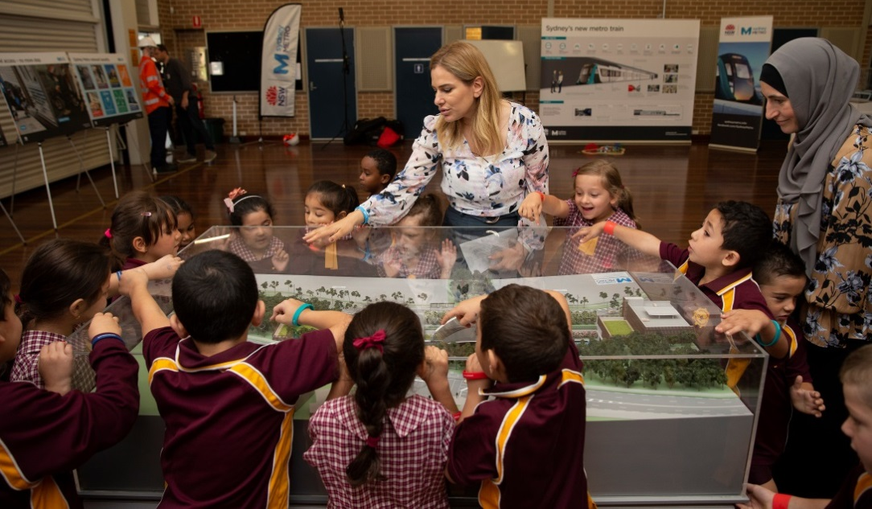
As part of learning experience 1, students observed artefacts belonging to Sydney Metro. To spark curiosity, teacher questioning was carefully planned to ensure that areas of student interest was captured. Photo courtesy of Sydney Metro. Image courtesy of Sydney Metro. Copyright of this image is vested in the Crown in right of Transport for NSW, subject to the Copyright Act 1968. This material is protected by copyright but may be reproduced without formal permission or charge for personal, in-house or non-commercial use. No part may be reproduced or reused for any commercial purposes whatsoever without written permission of: Sydney Metro (PO Box 588, North Ryde BC NSW 1670).

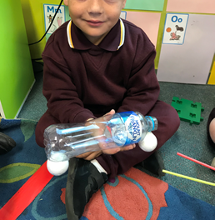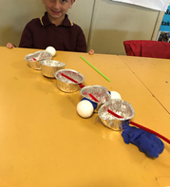

Critical and creative understanding
We wanted to build this capability in our students and so students used their creative side to build their own transport. Students were provided with various recyclable resources and were left on their own to create something. We were blown away with how students used the resources and made it work for them.
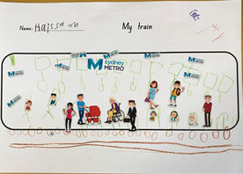
Experience 3
Experience 3: in our previous lesson, students agreed that trains were a faster means of transport but many had never been on a train. We watched a short clip on how to catch a train and students observed what could be found inside a train. Students found that there are: cameras on trains, seats, handlebars, maps, doors and spaces for wheelchairs.
Students were given a template resembling a train and had to include all the things they saw inside a train. The drawing to the left shows a camera facing computers in the top front part of the carriage, handlebars for people, windows, seats and spaces for wheelchairs.
Students were really curious about what it would be like to catch a train and so we decided to plan the following lesson to resemble the experience of catching a train.

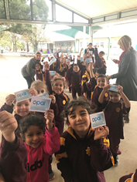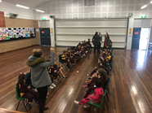
Experience 4
Experience 4: To provide students with an authentic experience we provided them with Opal cards printed on paper and students were required to tap on and tap off as they entered the hall.
Chairs were aligned to resemble the new Sydney Metro seating and a safety yellow line drawn on the floor.
The Direct Video Access (DVA) announcement for the Bankstown line was played as the students boarded the train. Students needed to wait for the instructor’s whistle as they reached their destination to exit the train. They also needed to tap off as they left the train station.
Students were provided with a map of Chullora and were asked to consider the advantages of a train station in Chullora. We wanted students to realise that something would need to go to make space for a train station. To the detriment of some students, they realised that some houses, roads and even shopping centres may need to go to make room for the trains.
Critical and creative understanding
We wanted to build this capability in our students. By role playing, students used their imagination to think creatively.
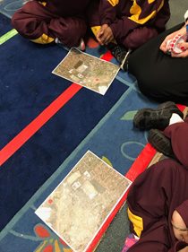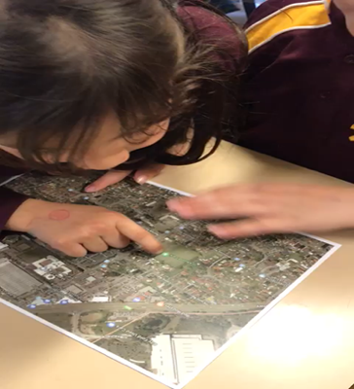
Experience 5
Experience 5: Based on the previous lesson and discussions, students were provided with a map of Chullora and needed to think critically about the best place to put a train station. Students were familiar with the local map and knew what the symbols meant and could identify familiar places on the map.
Students explain their reasoning behind their decision to place a train in a particular part of Chullora. We found many students felt that although the train would mean places and spaces had to go it also meant rebuilding in other parts of the town. Based on student reasoning and ideas we decided that students were going to create their own Chullora equipped with a train station but they also needed to think about where homes. shopping centres and roads would also need to go.
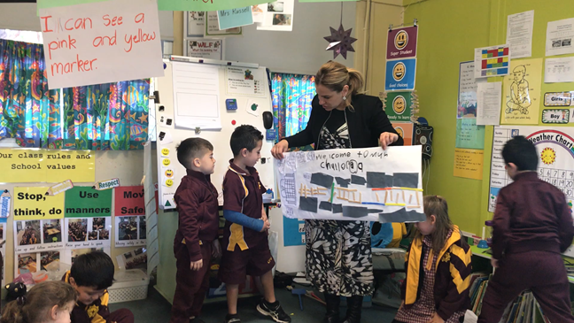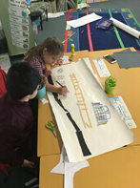
Experience 6
Experience 6: Students were given resources to re-create their own Chullora with a train station and needed to explain their reasoning. Students decided carefully where to place buildings, roads and houses for the community and explained just how a train would meet the needs of the community.
Through discussions, students expressed their opinions against having a train station in the area, in fear that it would mean their homes would need to make way or that their businesses would be effected so we decided to plan the next lesson around this concern.
Critical and creative understanding
Again, students had an opportunity to tap into their creative side and rebuild Chullora.

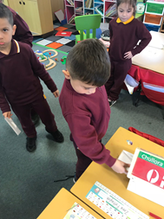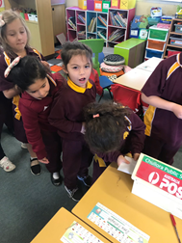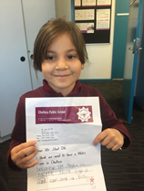
Bottom left and right: For learning experience 2, based on the
‘I wonder’ day questions and student curiosity, we found many students were not familiar with trains or different types of transport so we inquired into different types of transport. Students then had a chance to make their own transportation using recycled materials. We wanted students to think about transport and efficient ways to get to places near or far. Students concluded that trains were an efficient and quicker means to get to places further away from home.

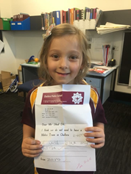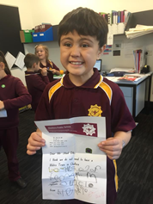
Experience 7: Students were introduced to their local MP. We wanted them to know that if they had an opinion or felt strongly about something they could always turn to the appropriate people and there is always someone to listen. Students were provided with an opportunity to give an opinion and explain their reasoning behind it. Some were for and some were against the train station and they expressed it in their letters.
Ethical understanding: As we moved further into the unit, students became aware that places and spaces needed to go to make room for a train station and this di not sit well with some students. It was evident that students developed empathy for their family and the community who would be affected by the train station and became more aware of their roles and responsibilities as citizens in relation to infrastructure planning and design.

Copyright
© State of New South Wales (Department of Education), 2019
The copyright material in this publication is subject to the Copyright Act 1968 (Cth), and is owned by the NSW Department of Education or, where indicated, by a party other than the NSW Department of Education. Copyright material which is owned by the NSW Department of Education is licensed under a Creative Commons Attribution 4.0 International (CC BY 4.0) licence
This licence allows you to:
- share – copy and redistribute the material in any medium or format
- adapt – remix, transform and build upon the material for any purpose, even commercially
Attribution should be given to:
© State of New South Wales (Department of Education), 2019.
Material in this publication not available under a Creative Commons licence includes:
- the Department of Education logo, other logos and trademark-protected material
- material owned by a third party that has been reproduced with permission. Permission will need to be obtained from the third party to re-use this material.
If this publication contains your work and you have any objection to such content, please contact legal@det.nsw.edu.au.

Links to third-party websites
If you use the links provided in this publication to access a third party’s website, you acknowledge that the terms of use, including licence terms set out on the third party’s website apply to the use which may be made of the materials on that third party’s website or where permitted by the Copyright Act 1968 (Cth).
The department accepts no responsibility for content on third-party websites.

Our school approached Sydney Metro to assist us with resources for the ‘I wonder’ day. A short video of the day is at youtu.be/ZznfE3po3uE (Transport for NSW, 2019) (2 minutes 37 seconds)
New South Wales Education Standards Authority. 2019, Geography K-10 Learning across the curriculum, accessed 16 April 2019, https://educationstandards.nsw.edu.au/wps/portal/nesa/k-10/learning-areas/hsie/geography-k-10/learning-across-the-curriculum
Ibid
‘Sydney Metro: 360 camera walk through new metro train’ (Transport for NSW, 2018) https://youtu.be/XyQ2JP8L7Kc
Contact Sydney Metro at sydneymetroedu@transport.nsw.gov.au to request stickers
‘A tour of Melbourne’s new high capacity Metro train (mockup)’ (ThebusofdoomFSX, 2018) youtu.be/VbVK7ekd364
Ibid
WALT is a way of clarifying learning objectives with students. WALT stands for ‘We are learning to’ and is followed by the learning objective
‘London Underground Train* | Trains for Kids’ (Things That Go TV!, 2013) youtu.be/FdJ8gilCpfA
Train announcement ‘DVA #40: Campbelltown – City Circle via Bankstown (Limited Stops)’ (TSE SecretAni, 2017) youtu.be/yFc1g0YQRfQ
New South Wales Education Standards Authority. op.cit.
‘Sydney Metro: Fast Tracking the Future education program an introduction for primary school students’ (Transport for NSW, 2019) (4 minutes 1 second): youtu.be/G-nET2o1av4
Map:Link to Sydney trains network map: https://transportnsw.info/sydney-rail-network-map
Ibid
Ibid
Link to the webpage for the local member for Lakemba at the time this unit was written https://www.parliament.nsw.gov.au/members/Pages/member-details.aspx?pk=110
Link to website of the local MP at the time this unit was written: http://www.nswlabor.org.au/jihaddib
Ibid

