Early Stage 1 Geography – Sydney Metro and me
Artarmon Public School is situated on the lower North Shore, opened in 1910.There are approximately 1200 students enrolled from Kindergarten to Year 6. Students come from diverse language backgrounds with over 80% from language backgrounds other than English. There are many cultures represented within the school community.
Artarmon Public School has a reputation for excellence in academic achievement and is also a centre for four opportunity classes. It provides a rich educational experience for students K–6, with particular emphasis on curriculum differentiation, effective integration of ICT and a strong creative arts program.

Sydney Metro and me
Early Stage 1 – duration 8 weeks

Unit context
This unit was written by William Carr of Artarmon Public School.
It was created, trialled and peer reviewed as part of a professional development program in inquiry-based learning for primary and secondary school teachers. The professional development courses were part of a pilot partnership between the NSW Government’s Sydney Metro transport agency and Western Sydney University. Facilitated by Western Sydney University’s Education Knowledge Network, the professional development program aimed to develop teacher expertise in inquiry-based learning using a real-life example of a major infrastructure project in delivery stage.
Sydney Metro is Australia’s biggest public transport project.
The unit is aligned to © NSW Education Standards Authority (NESA) syllabuses, specifically the Geography K-10 Syllabus (2015). for and on behalf of the Crown in right of the State of New South Wales, 2019.

Syllabus links
General capabilities and cross-curriculum priorities | Outcomes | Skills | Concepts
Critical and creative thinking  Ethical understanding  Literacy | By end of the unit a student:  - GEe-1 identifies places and develops an understanding of the importance of places to people.  - GEe-2 communicates geographical information and uses geographical tools. | Students:  - Investigate the importance of places they live in and belong to, for example: (ACHGK002, ACHGK004)  - Discussion of why places are special and how people care for them.  - Students acquire information by observing, talking to others and viewing, reading and/or listening to texts. They use geographical tools and communicate geographical information in a range of forms. Students reflect on their learning from the findings of their inquiry.  - Students ask questions and use known facts to explore mathematical problems and develop fluency with mathematical ideas. They use everyday language, concrete materials and informal recordings to demonstrate understanding and link mathematical ideas. | In this unit students will learn about:  - Place  - Environment  - Interconnection  - Sustainability

Key inquiry questions
- What places do I know?
- What makes a place special?
Teaching, learning and assessment | Resources and technology
Session 1: The places in our community  Show the students a selection of photos of the different places in the Artarmon community. Some ideas: the school, the park, the post office, the police station, the grocer, the shopping centre and so on.  Students are to discuss:  - Who uses this place and why?  - What is important about this place to me?  - Extension: Who else is this place important to, and why?  ‘Wonder’ worksheets  Model an effective use of the ‘Wonder’ worksheet using a large printout.  Choose an important place in the community. The school is a good one to do as a class – everyone knows it!  Come up with three ‘I wonder’ statements about the place. Draw on student ideas here, and model inquiry thinking by thinking out loud.  For example: ‘I wonder how old the school is’, ‘I wonder how many students there are at the school’, ‘I wonder how everyone gets to school’.  Discuss with students how they could find out the answers to each of these wonderings.  Students complete a ‘Wonder’ worksheet for a place of their choosing.  In this worksheet, students need to identify an important place in the community, and come up with three ‘I wonder’ statements about their place.  After writing the ‘I wonder’ statements, students draw and colour a picture of their special place. Put these up on a ‘Wonder’ wall | - Images of local community  - ‘Wonder’ worksheets (page 7 of this document)  - ‘Wonder’ wall
Session 2: See, think, wonder  This session will focus on the train station. Display a slide with images to promote student thinking about train stations such as those on the ‘See, think, wonder’ slide on page 10 of this document. Give the students two minutes to observe the images silently. Encourage them to keep their thoughts locked in their heads until it is sharing time.  As a class, discuss the things students can see in the pictures, what they think about the pictures, and what they wonder about the pictures.  Record their thoughts as these will be important in guiding the direction of their learning (as per student work sample on page 12 of this document | Large printout for the ‘See, think, wonder’ slide on page 10 of this document.
Session 3: A walk to the local station
Before the walk:
Call the train station to let them know you’re coming, and ensure there will be someone there to talk to the group.
Have a discussion as a class about the local train station. Students use post-it notes to create visual data displays for some of the following questions:
- How many people have been to the train station?
- How often do you go to the train station?
- How often does your Mum or Dad go to the train station?
Discuss the results of the data displays.
Brainstorm some questions the students might have about the train station. Use question words (who, how, why, what, when, where) as question starters for the students.
Students write down 1-3 questions they have about the train station (see student work sample on page 12 of this document)
Brief students on safety at the station including:
- crossing roads (to get there and back)
- staying together (buddies)
- staying away from the edge of the platform
- listening to teachers’ instructions.
At the station:
Students sit on the platform. Students are chosen to read out their questions to the train station staff member.
While students are seated, observe features of the train station. What do they have there for the commuters?
After the walk:
Guide the class in a discussion reflecting on the visit to the station.
- What did you learn about the train station?
- Why is our train station important?
- What are some things that could make our train station better?
What would happen if we didn’t have a train station? How would people get to work? What would happen to the roads?
Session 4: Introducing Sydney Metro  Watch videos about Sydney Metro that include:  - new stations  - tunnelling  - new trains.  Watch the videos twice. On the second viewing, pause to explain as needed.  Students come up with ‘I wonder’ statements about the Sydney Metro project. Write these down and put them up on the ‘Wonder’ wall. You may need to group similar questions.  Students get into their design groups (3-4 students per group). In these groups, give them a piece of paper split into quadrants.  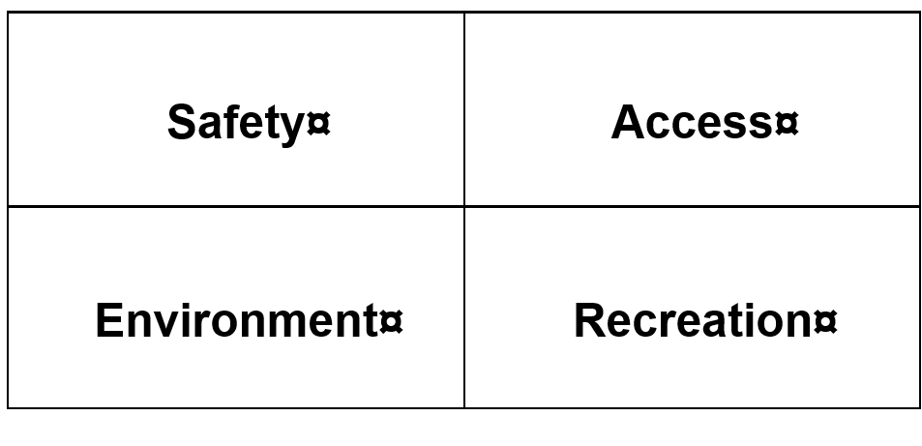  Students brainstorm ways that a train station’s design could accommodate these four factors. A student work sample can be found on page12 of this document. | A video that provides an introduction to Sydney Metro such as ‘Sydney Metro: FastTracking the Future education program an introduction for primary school students’ (Transport for NSW, 2019) (4 minutes 1 second)  ‘Sydney Metro: start of city tunnelling’ (Transport for NSW, 2018) (3 minute 08 seconds)  ‘Sydney Metro: first complete train journey’ (Transport for NSW, 2019) (1 minute 52 seconds)  Station design brainstorm scaffold page 8 of this document
Session 5: Designing a new station for Artarmon  As a class, discuss some of the features of train stations that groups thought of in the last session to ensure commuter safety, ease of access, recreational opportunities, and minimal environmental impact.  The focus of this session is to take the ideas the groups formed in the last session and to bring them together in the design of a new station. In the same groups as the last session, students use a station design scaffold (page 9) to design their train stations. While students are working in their groups, the teacher should check in on each group and have discussions about how their station meets the criteria:  - commuter safety  - ease of access (how to get in and out without crowds)  - recreation  - environmental impact.  Students can refer to their ideas from the last session. Make sure they have access to their brainstorm from the last session. The teacher should help direct students back to these ideas and help them think about how they could be implemented into the design.  After the design is complete, students must think about materials they will need in order to construct their model station. It would be helpful here for the teacher to provide a list of suitable materials for them to consider using in their model and a list of materials that can be provided by the school, other materials will need to be brought in by the students.  Explain how the building process will work so that students have a good idea of materials that will work well. You will need to consider what the stations will be built on top of (a large, flattened cardboard box works well).  Once the groups have decided which materials need to be brought in by which members, they should write a list of the items they’re responsible for to take home. | Station design scaffold (page 9 of this document)
Session 6: Build day  Provide students with adequate time and support to build their model train stations, ensuring they have access to their design to refer to throughout the build.  This could be done over a number of sessions, or in one ‘build day’.  If possible, parent helpers should be invited into the classroom to assist with the build. | Building materials such as boxes and toilet rolls brought in from home.
Session 7: Presenting our design to the community
Once the designs are constructed, students must present their design to the ‘community’ (class), making sure they explain how the station will improve the experience for commuters in Artarmon. Encourage students to present as a group, ensuring each member contributes.
The class should be given an opportunity to provide feedback after the presentation, explaining things about the design that they would enjoy as a member of the Artarmon community.

Assessment
The assessment for this unit will be completed using an assessment rubric such as the one on page 11 of this document.
Assessment is based on the station design (Session 5) and the presentation (Session 7), not on the model station itself.
There will be an opportunity for students to provide peer feedback, which will be recorded by the teacher.

Wonder worksheet

I wonder…
Name:

3 things I wonder about

Station design brainstorm scaffold
Designers’ names:

Safety: | Access:

Environment: | Recreation

Station design scaffold

Design:

Materials we need:

See, think, wonder slide
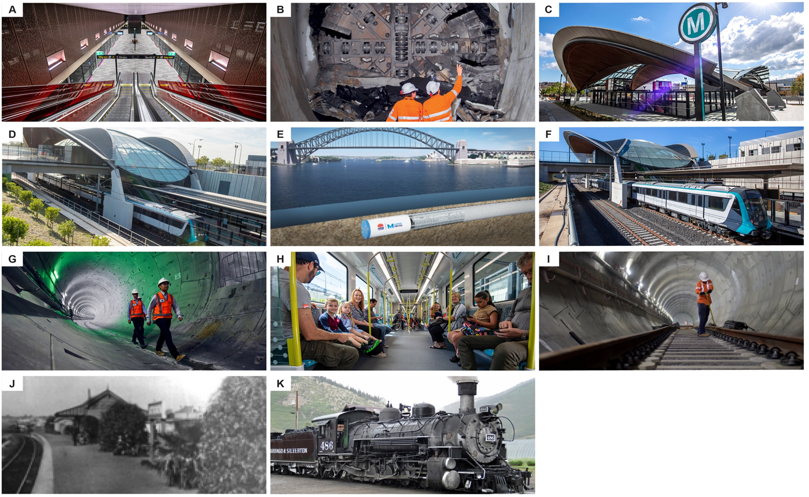
Images A-I: Various images of the Sydney Metro. Copyright of images Vested in the Crown in right of Transport for NSW, subject to the Copyright Act 1968. This material is protected by copyright but may be reproduced without formal permission or charge for personal, in-house or non-commercial use. No part may be reproduced or reused for any commercial purposes whatsoever without written permission of: Sydney Metro (PO Box 588, North Ryde BC NSW 1670). Image J: Artarmon railway station (Willoughby Library collection); Image K Steam train by James St. John CC BY 2.0.=

Train station design assessment
Students:
Features of design: | 0 | 1 | 2 | 3 | Notes
Safety
Accessibility
Environment
Recreation

Understanding (oral presetation)
Expresses resoning behind station features | Yes | No
Safety
Accessibility
Environment
Recreation

Peer feedback

Photos from the unit and work samples

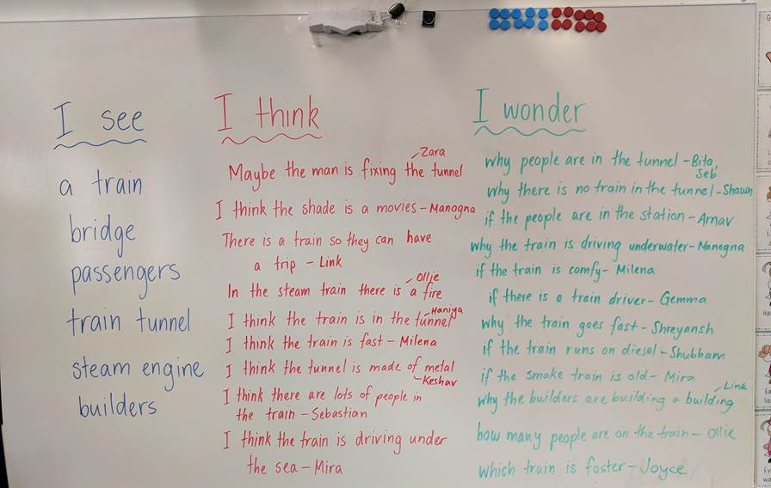
Top left: Record of student wonderings after the ‘See, think, wonder’ activity
Top right: Student work sample of questions composed for the visit to the train station
Bottom right: Student work sample of completed design scaffold
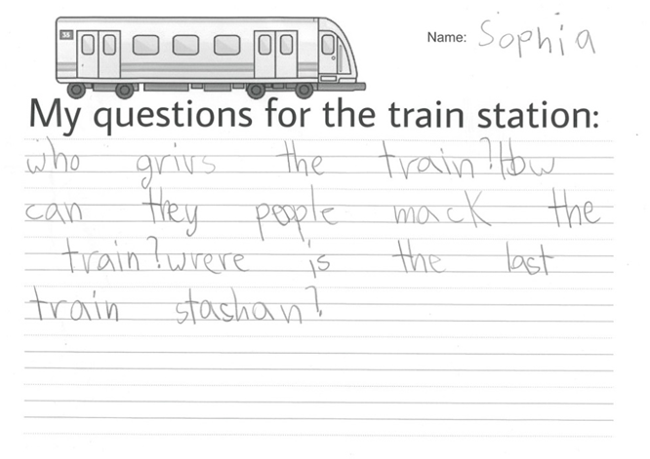
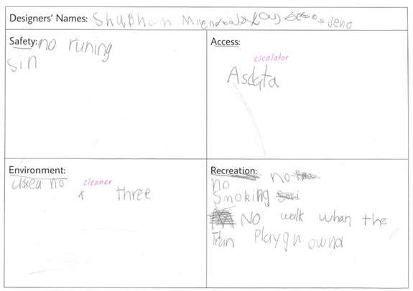
Photos from the unit and work samples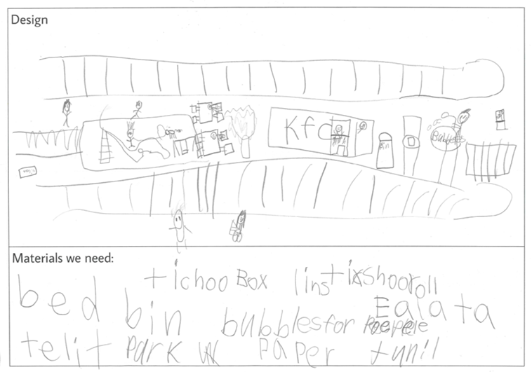
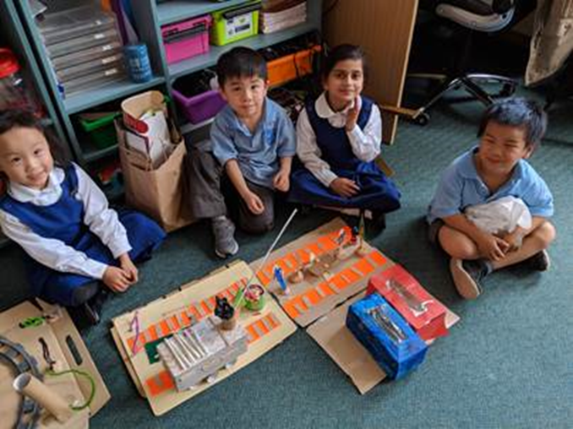

Copyright
© State of New South Wales (Department of Education), 2019
The copyright material in this publication is subject to the Copyright Act 1968 (Cth), and is owned by the NSW Department of Education or, where indicated, by a party other than the NSW Department of Education. Copyright material which is owned by the NSW Department of Education is licensed under a Creative Commons Attribution 4.0 International (CC BY 4.0) licence.
This licence allows you to:
- share – copy and redistribute the material in any medium or format
- adapt – remix, transform and build upon the material for any purpose, even commercially.
Attribution should be given to:
© State of New South Wales (Department of Education), 2019.
Material in this publication not available under a Creative Commons licence includes:
- the Department of Education logo, other logos and trademark-protected material
- material owned by a third party that has been reproduced with permission. Permission will need to be obtained from the third party to re-use this material.
If this publication contains your work and you have an objection to such content, please contact legal@det.nsw.edu.au.

Links to third-party websites
If you use the links provided in this publication to access a third party’s website, you acknowledge that the terms of use, including licence terms set out on the third party’s website apply to the use which may be made of the materials on that third party’s website or where permitted by the Copyright Act 1968 (Cth).
The department accepts no responsibility for content on third-party websites.

Sydney Metro: FastTracking the Future education program an introduction for primary school students’ https://youtu.be/G-nET2o1av4
‘Sydney Metro: first complete train journey’ https://youtu.be/2CmvQRSKg8s
‘Sydney Metro: first complete train journey’ https://youtu.be/i-FtJc1YdWA

